## 2 How are studies concerning Syndemic Theory applied to MSM conducted?

### 2.1 General characteristics of included studies

The publication date of the studies range from 2003 to 2021 with a marked increase in the number papers published yearly from 2013 onward as illustrated in 1.2. Apart from the quantitative increase in the number of studies, there’s also a qualitative increase in the diversity of the studies, both in the type of design used and the countries where the studies are conducted.

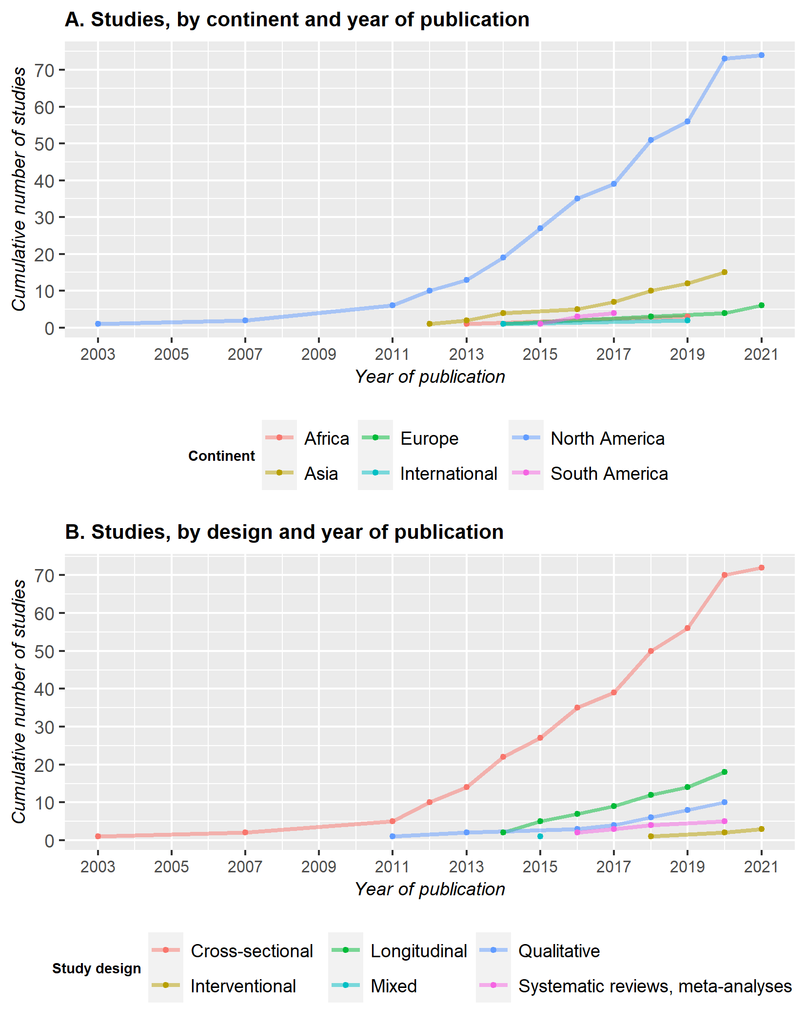

Figure 1.2: Plot of the cumulative number of studies published yearly, grouped by continent (A) and design (B)

However, despite this growing diversity, the vast majority of studies are conducted in North America (N = 74), with a large predominance of studies in the United States of America (N= 62). The majority of the remaining studies were then located in Asia (N = 15) or in Europe (N = 6). South America and Africa were the least represented continents, with only 4 and 3 studies respectively.

In terms of design, a similar pattern appears, with most of the studies employing a cross-sectional design (N = 72). The number of longitudinal studies steadily grew since 2014 but only represents 17% of the papers to this day. Qualitative studies are also under-represented, with only 10 papers. Of note, we only identified 1 mixed design[2] ; this study employed a cross-sectional design for the quantitative part and in-depth interviews analyzed through grounded theory for the qualitative part. The first systematic reviews and meta-analyses were published recently, in 2016 while the first interventional studies were published in 2018.

Finally, the median sample size of the studies was 450 (range : 15 - 24 274) and the mean age of the participants, when reported ranged from 16 to 57.89.

# References

1 Stall R, Mills TC, Williamson J, *et al.* Association of co-occurring psychosocial health problems and increased vulnerability to HIV/AIDS among urban men who have sex with men. *American Journal of Public Health* 2003;**93**:939–42. doi:[10.2105/AJPH.93.6.939](https://doi.org/10.2105/AJPH.93.6.939)

2 Buttram ME, Kurtz SP. A mixed methods study of health and social disparities among substance-using african american/black men who have sex with men. *Journal of Racial and Ethnic Health Disparities* 2015;**2**:1–0. doi:[10.1007/s40615-014-0042-2](https://doi.org/10.1007/s40615-014-0042-2)